**CG-Assignment**

**Bezier Curve**

**Program:**

Writing a program to print Bezier Curve

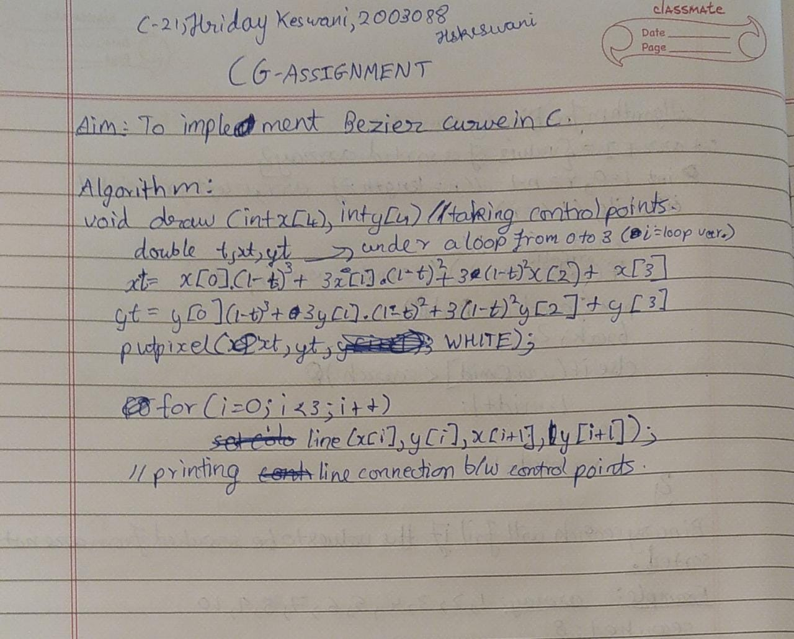

**Code:**

#include<stdio.h>

#include<graphics.h>

#include<math.h>

#include<conio.h>

//int x[4]={200,100,80,70};

//int y[4]={200,150,75,60};

void bezier (int x[4],int y[4])

{

int i;

double t,xt,yt;

for (t = 0.0; t < 1.0; t += 0.0005)

{

xt = pow(1-t,3)*x[0]+3*t*pow(1-t,2)*x[1]+3*pow(t,2)*(1-t)*x[2]+pow(t,3)*x[3];

yt = pow(1-t,3)*y[0]+3*t*pow(1-t,2)*y[1]+3*pow(t,2)*(1-t)*y[2]+pow(t,3)*y[3];

putpixel (xt, yt,WHITE);

}

for (i=0; i<3; i++){

setcolor(YELLOW);

line(x[i], y[i], x[i+1], y[i+1]);

setcolor(WHITE);

}

}

void main(){

int x[4];

int y[4];

int i;

int gd = DETECT,gm;

initgraph(&gd,&gm,"c:\\turboc3\\bgi");

printf("Enter the control points:\n");

for(i=0;i<4;i++){

scanf("%d%d",&x[i],&y[i]);

}

bezier(x,y);

prtinf("\n\nHriday Keswani\nRoll no. 2003088\nC-21");

getch();

closegraph();

}

**Output:**

